Geethanjali College of Engineering and Technology
Department of ECE
Innovations in Teaching
The key role of a teacher is to teach, which can be understood as meaning to facilitate learning of some target curriculum. Teaching is therefore intimately tied to notions of learning and there is a sense that if students do not learn then whatever the teacher is doing does not deserve the label of ‘teaching’. The use of innovative methods in educational institutions has the potential not only to improve education, but also to empower people, strengthen governance and galvanize the effort to achieve the human development goals for the country.

Traditional Teaching Method: In the pre-technology education context the teacher is the sender, the educational material is the information and the student is the receiver of the information. In terms of the delivery medium, the educator can deliver the message via the “chalk-and- talk” method and LCD projector transparencies. This learning perspective is a popular technique, which has been used for decades as an educational strategy in all institutions of learning. Basically teacher controls the instructional process, the content is delivered to the entire class and the teacher tends to emphasize factual knowledge.

Innovative Teaching Methods: Following innovative learning methods are initiated and implemented by the faculty for students to learn in a better manner.
1. Collaborative Learning
2. Through Display of Working Models
3. Facilitating through Group Learning
4. Teaching through Value Added Courses
5. Providing Experiential Learning
6. Through Guest Lectures, Industrial Visits, Field trips
7. Product/ Project Based Learning
8. Through Display of Animation
9. Continuous Interaction with student

Teaching Using Physical Models  In the course, Microwave Engineering, while explaining about the Directional coupler to the students of IV Year ECE, the physical device of Directional coupler was demonstrated to the students to get them a better understanding about the working of the device. Similarly concepts of E-plane Tee, H- plane Tee, Circulator, Magic Tee, Reflex Klystron Oscillator were explained using physical devices.  Name of the Teacher: Prof. B. Hari Kumar |  |  | 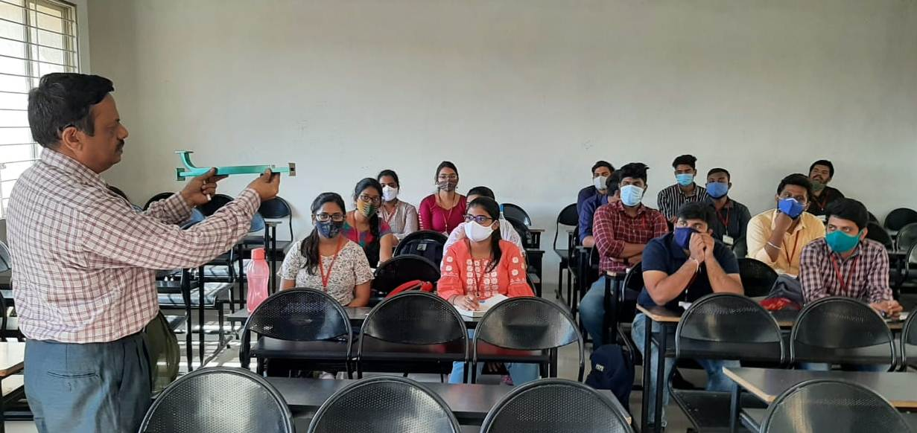
Through Workshops  A Two day workshop for students was conducted on “Arduino Based Internet of Things with Hands – on Practice” on 17th and 18th February, 2018 for 3rd year ECE students in association with M/s Technotran Electronic Solutions, under ISTE Student Chapter, Hyderabad Section. 62 students participated with enthusiasm in this program, to learn the Arduino and its applications. |  |  | 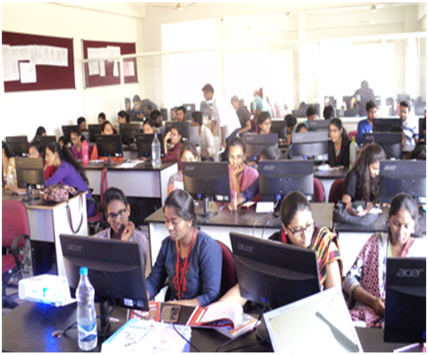
Peer Learning  The Digital Electronics Group (Group IV), of ECE Department organized a Peer Learning Three day Workshop with Hands on training on “Real Time Projects Design and Development using Arduino-For Beginners” on 2nd, 3rd and 4th March, 2018 at Block - I Seminar Hall-2. This event was conducted under IETE student forum, for the students of III ECE and EEE in association with Final Year Students of ECE. The resource persons are Chaganti Mounica, Pranav Raju A, Paramakusam Niharika and Vecha Pavan Kumar from ECE final Year. The main objective was to build confidence in students to do their projects on their own with the help of their seniors, encouraging |  |  | 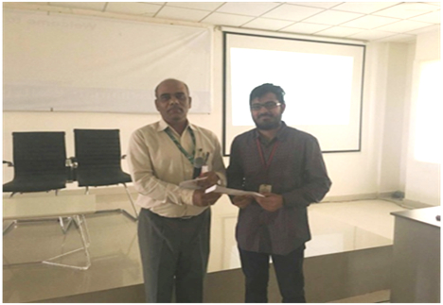
Peer Learning  - A Peer Learning program was conducted on “Life Skills and Communication Skills” to 1st year ECE students by Ms. Vaishnavi and Mr. Praneeth of 2nd year ECE . It was held on 6th Jan, 2018 in Seminar Hall-4 Block-IIand 100 1st year students participated.  - The Group IV (Digital Electronics Group) of ECE Department,organized a Peer Learning program (Lecture) on “Advanced Technology Trends Useful For The Mini and Major Projects Execution” on 27th December 2017 in Block -1 Seminar Hall-1for III year ECE Students . The speakers were Y. Sai Vishwanath (Roll No. 14R11A04B6) of IV Year ECE B-SEC and A. Pranav Raju (Roll No. 14R11A04M6) of IV Yr ECE D-SEC. 130 students of ECE 3rd year attended this program. |  |  | 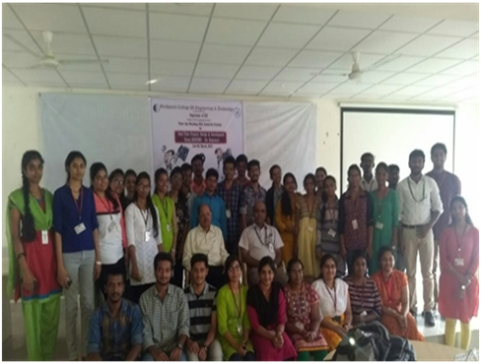  Group photo of the Team
Through Workshops  A “Two-day Workshop on Raspberry Pi Jam” was conducted on 2nd and 3rd, March, 2019. Mr. A. Subramanyam, Asst. Professor was the coordinator. A total of 70 students (Internal Students-55 members, External Students -15 members) participated in the event. The workshop was organized to educate the students with hands-on experience using Raspberry Pi boards for digital making. The workshop was organized in association with Raspberry Pi Foundation, UK. |  |  | 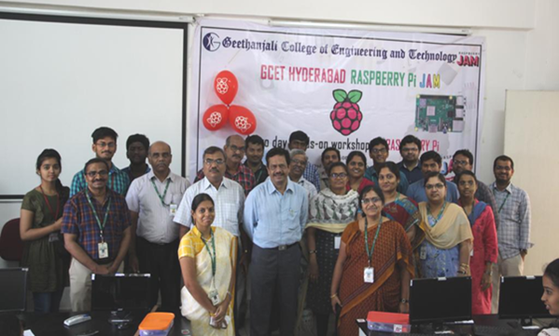
Value Addition for EDC Course  A “Two-day Workshop on PCB Design and Fabrication” for II year students was organized by Group -V (Analog Electronics and Instrumentation) on 22nd and 23rd Feb, 2019. 79 students participated in the workshop. Dr. S. Suryanarayana, Professor was the coordinator of the workshop. A team consisting of 4 persons headed by Mr. Nabi Shareef from Physitech Electronics Ltd., Hyderabad acted as resource persons for the workshop. Different stages of PCB fabrication were learnt by the students. |  |  | 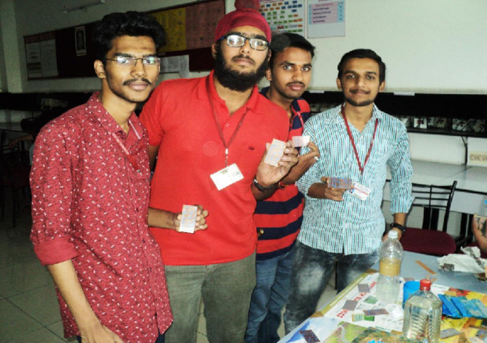
Project Based Learning
As part of Innovative teaching and learning methodology, the Department of ECE has proposed Project Based Learning in the following courses in association with Vishwanikethan, Mumbai.
- Analog Communications Lab for II year II Semester
- Linear Integrated Circuits Lab for II year II Semester
- Simulation Lab for II year II Semester
- Switching Theory and Logic Design Lab for III year II Semester
- Digital Signal Processing Lab for III year II Semester
- VLSI Lab for III year II Semester.
On 4th and 5th March, 2020, the associated faculty presented their PBL models about course level PBL to the faculty of Vishwanikethan. Dr. Santhosh Nemade, and Prof. Wagh Sharad Shesh Rao, faculty members from Department of E&TC of Vishwanikethan attended the session. Dr. P.Srihari, Dr. S.Spandana, Dr.S.Saritha, Prof. O.V.P.R.Siva Kumar, Mr. A.Subramanyam, Mr. P.Naresh Kumar, Mrs. M.Laxmi, Mr. Ch.Sandeep faculty from Department of ECE presented their PBL models about course level PBL to the faculty of Vishwanikethan on the above labs.
A Two day Project competition was held in Digital Design under Project Based Learning on 10th and 11th October 2019 by Group IV (Digital Electronics) under the guidance of Prof.K.Somasekhara Rao,
S.No | Prize | Roll no. | Name of the  student | Project Title
1 | 1st | 18R11A0428 | K Tejaswi | Density based Automatic Traffic control system
2 |  | 18R11A0432 | M Keerthana
3 |  | 18R11A0446 | Y Saketh
4 | 2nd | 18R11A0488 | S Ramya | Smart Office
5 |  | 18R11A0490 | S Ruchishun
6 |  | 18R11A0478 | M Srilekha
7 | 3rd | 18R11A0473 | K Vishwesh | 2 bit Password checker
8 |  | 18R11A0475 | L Nithin
Mr.Ch.Sandeep and Mr.M.Anand. Students have done various projects using the concepts of the course “Digital Design”.
Through Guest Lectures  A Guest lecture was organized by Group III (Communications) under IEEE SB, GCET on 30th September 2019 on “Role of Communication, Navigation and Surveillance in Aviation”, by Dr.Ch.Mahesh, SM (CNS), Airport Authority of India (AAI), HAL Hyderabad for IV Year students. 60 students have attended the lecture. |  | 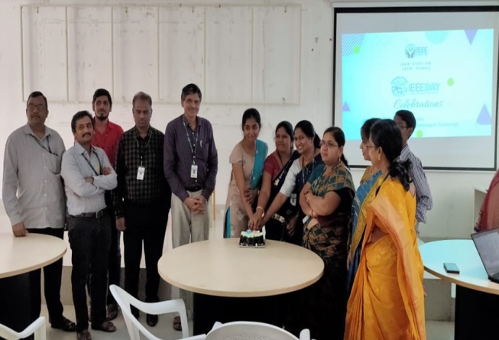
Through Participative Learning  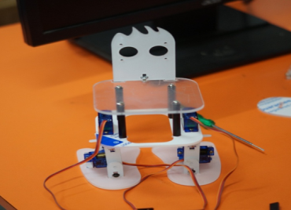  A two day National level workshop on “Humanoid Robot Development”was organized for B.Tech students by ISTE student chapter and Incubation centre in association with EduxLabs, Gurugram on 9th and 10th August, 2019. This event was coordinated by Ms.M.Soujanya, Assoc Prof. on behalf of ECE department. 48 students participated in this workshop. |  | 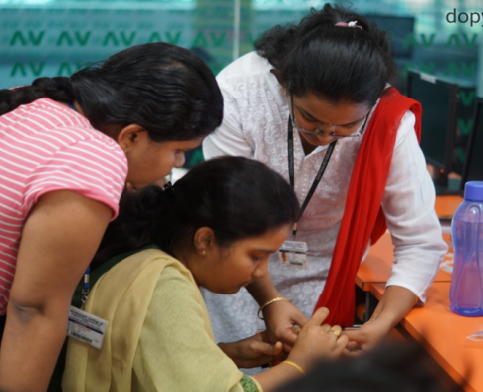
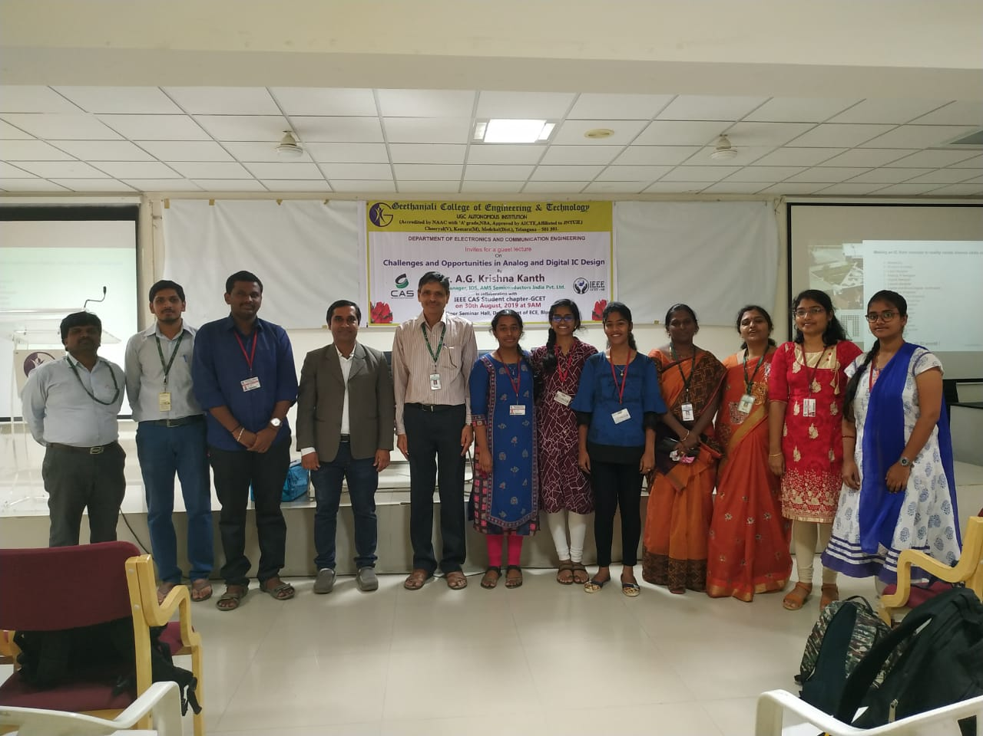
Under Professional Bodies
A Guest lecture was organized under IEEE-CAS on 30th August 2019 on “Challenges and opportunities in Analog & Digital IC Design”, by Dr.A.G.KrishnaKanth, Senior Manager,AMS Semiconductors, Hyderabad for III year students.

Through Centers of Excellence  The Center of Excellence in VLSI Design and Embedded Systems and IoT are training the students in core areas.  Mr.RajaBandi, Founder - Lucid VLSI delivered an invited talk on 16th October 2019, followed ny a Two Week workshop for students on "Advanced Digital Design using VERILOG HDL | 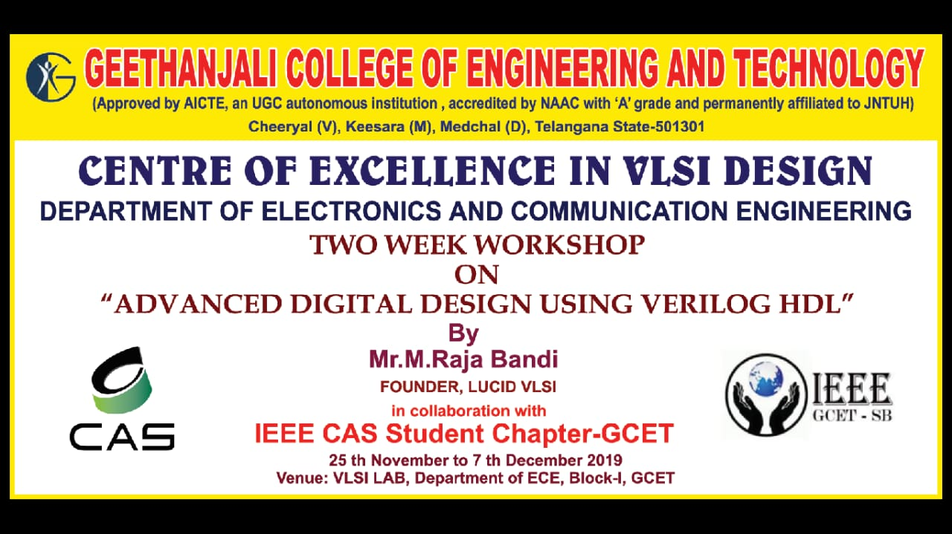
Value Addition Course
A Student Development Program on Arduino Programming and Node MCU for IoT was conducted for four weeks from 7th January, 2020. The resource person were Mr. Ch.Sandeep, Mr. M.Anand and Mr. P.Chandra Prakash Reddy from the Depatment of ECE, GCET. 100 students were trained in this program
Through Quiz
IEEE SPS-SB organized online quiz competition "TATTVA" on Signal Modulation Techniques on 19th April, 2020. A total of 84 student from 36 engineering colleges (35 across India and one from Bangladesh). This quiz was conducted to II Year and III year students involving 7 IEEE Sections
Through Quiz
IEEE SPS SB GCET organized an online quiz competition "OPA - BRAINIE" on Linear Integrated Circuits and its applications for II year and III year students on 10th May, 2020. A total of 132 students from 28 engineering colleges (including one from Bangladesh) have participated.
Through Training (Events under Center of Excellence- VLSI)
A three-day training session on "Advanced Digital Design using Verilog HDL" was conducted from 24th -26th February, 2020 by Mr.RajaBandi, Lucid VLSI. This was intended to train the students for mini projects. 22 students attended this session

Through Animation Videos
The concepts of modulation techniques can be understood in a better way by the students if animated videos are presented to them.
The concept of Amplitude Modulation technique wherein the amplitude of the carrier wave is modified according to the instantaneous amplitude of the message signal is taught using animated videos that are available in the internet.
Name of the Teacher: Dr. P. Srihari
Through Participation in JHUB/ Hackathons/ TechExpos
(Self Learning)
Students are encouraged to participate in various academic activities such as JHUBs/ Hackathons/ AICTE ChaatraVishwakarma Awards etc. that bring out their innovation and creativity. The theoretical concepts explained in the classroom are broadened and are put into practice by the students by participating in these academic competitions.
College has been organizing these activities on a regular basis that improve critical thinking of students.
Some of the activities hosted by our college are:

List of events
S.No | Events | Date
1 | Hackathon 2018 | January 20, 2018
2 | 36-Hr Smart India Hackathon | January5 -6, 2019
3 | TECHEXPO’19 | March 6,2019
4 | RASPBERRY Pi JAM | March 2-3, 2019
5 | JHUB EXCITE | May 11 – June 30, 2018

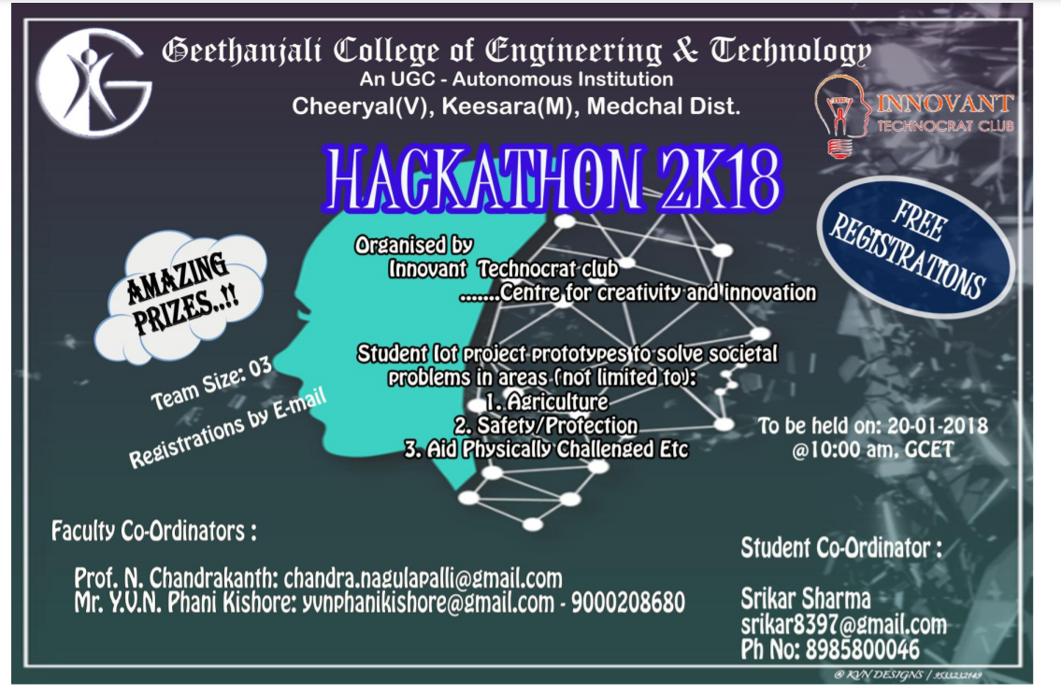

Through Use of Software
The concepts of radiation of an antenna is very hard to explain in terms of the equations. The radiation pattern of an antenna is also difficult to visualize as it is a 3-D pattern. While teaching the Antennas and Propagation course in III Year – I semester, the teachers are taking the help of HFSS software (student version) to explain the concepts of different antennas and to show them how radiation pattern of an antenna appears in 3-D. A good number of students have done projects in the area of Microstrip antennas using the HFSS software.
