Department of ece

Strategic Planning of the Department
(2020-25)

Geethanjali College of Engineering and Technology
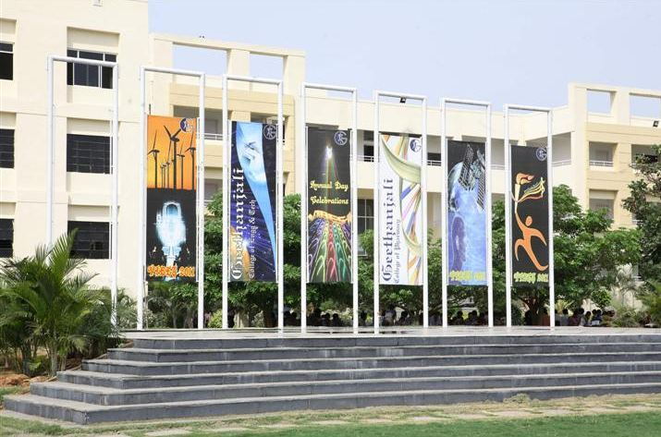
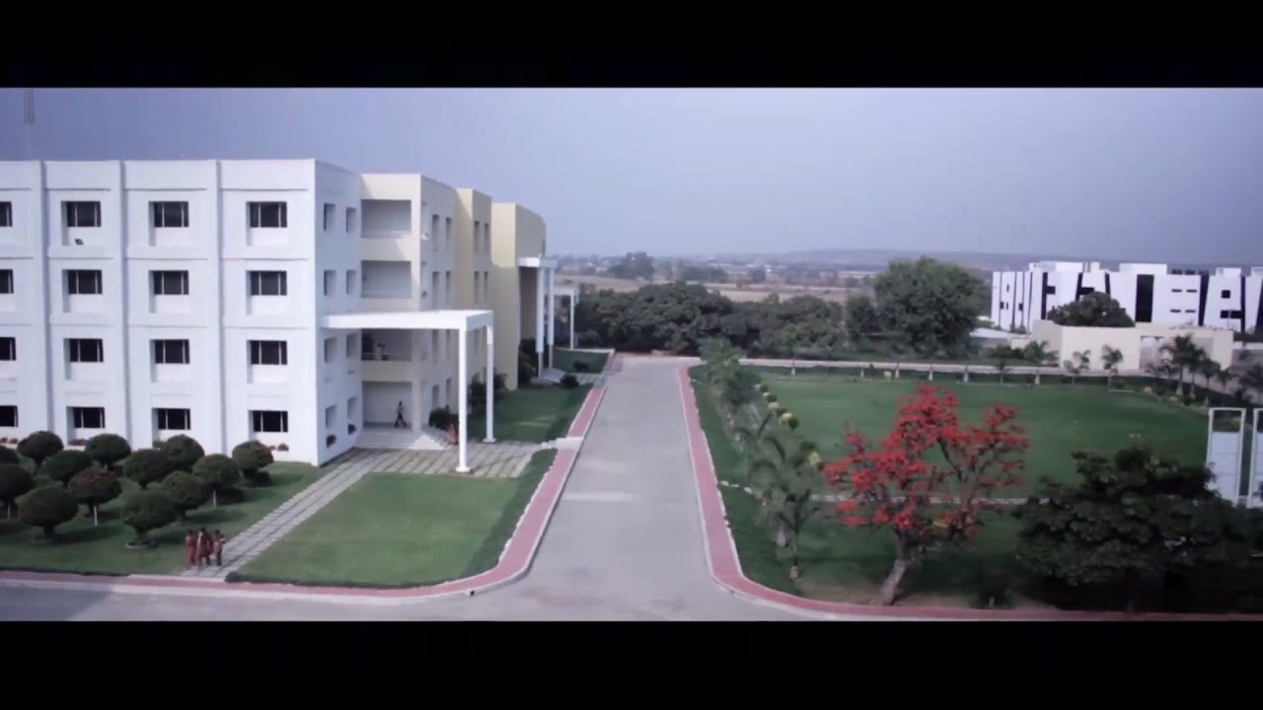
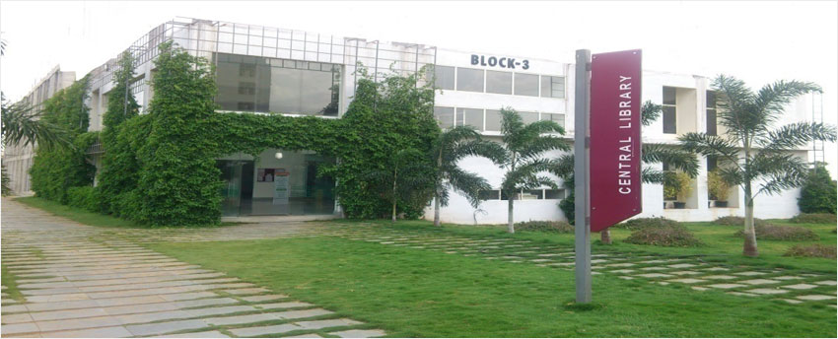
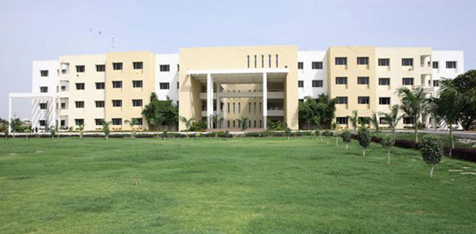

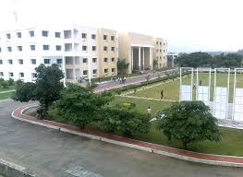

STRATEGIC PLAN OF ECE DEPARTMENT
Vision of the Institution
Geethanjali visualizes dissemination of knowledge and skills to students, who would eventually contribute to well being of the people of the nation and global community.
Mission of the Institution
- To impart adequate fundamental knowledge in all basic sciences and engineering, technical and Inter-personal skills to students.
- To bring out creativity in students that would promote innovation, research and entrepreneurship.
- To preserve and promote cultural heritage, humanistic and spiritual values promoting peace and harmony in society.
Vision of the Department
To impart quality technical education in Electronics and Communication Engineering emphasizing analysis, design/synthesis and evaluation of hardware/ embedded software using various Electronic Design Automation (EDA) tools with accent on creativity, innovation and research thereby producing competent engineers who can meet global challenges with societal commitment.
Mission of the Department
- To impart quality education in fundamentals of basic sciences, mathematics, electronics and communication engineering through innovative teaching-learning processes.
- To facilitate Graduates define, design, and solve engineering problems in the field of Electronics and Communication Engineering using various Electronic Design Automation (EDA) tools.
- To encourage research culture among faculty and students thereby facilitating them to be creative and innovative through constant interaction with R & D organizations and Industry.
- To inculcate teamwork, imbibe leadership qualities, professional ethics and social responsibilities in students and faculty.

Quality Policy
We aspire to continuously improve our performance through systematic monitoring and up-gradation of all aspects of Teaching Learning Process.

Core Values
Values: are inspired by the saying "Vidwan Sarvathra Poojyathe" (A knowledgeable person is worshipped everywhere)
Ambience: Provide the ambience to nurture the spirit of research for students and staff.
Care: Extend care, concern and equal opportunity to students & employees.
Collaborate: Collaborate within the college, with Industry and world.
Respect: Treat one and another with dignity and respect
Excellence: Facilitate excellent teaching-learning process.
Discover: Discover the integration of experience with academic knowledge.
About Geethanjali:
Geethanjali College of Engineering and Technology (GCET) was established in the year 2005 under the aegis of Teja Educational Society with the sole objective of providing quality technical education accessible and affordable to youth of our nation. The college has excellent infrastructural facilities and modern laboratories. It has highly competent and dedicated faculty. College has been recognized as an R&D centre by Scientific and Industrial Research Organization (SIRO). The college offers Undergraduate programs in various engineering branches, namely, CSE, IT, ECE, EEE, ME and CE with a total intake of 960 students. Four of its undergraduate programs, namely, CSE, ECE, EEE and ME have been accredited by NBA. The college is accredited by NAAC ‘A’ grade with a score of 3.36 in June 2017, which is the highest by any institution that has gone for accreditation for the first time in both states of TS and AP. The college was conferred “Autonomous” status by UGC with effect from AY 2016-17. It has ISO 9001:2008 certification. The college also offers postgraduate program in MBA with an intake of 60 students and M.Tech program with Computer Science specialization in Department of CSE. The college is sanctioned with sponsored research projects from UGC, DST, DRDO and JNTUH-TEQIP. The college has also been granted EDC, FDP and MODROBS by AICTE. More than 80% of eligible students are placed in several MNCs. College has entered into MoUs with several reputed organizations for mutual benefits such as students projects , expert lectures, industrial visits etc.
Programs Offered:
Undergraduate Programs
S.No | Branch | Sanctioned Intake
1. | Civil Engineering | 60
2. | Electrical and Electronics Engineering | 60
3. | Mechanical Engineering | 60
4. | Electronics and Communication Engineering | 240
5. | Computer Science & Engineering | 240
6. | CSE - Artificial Intelligence and Machine Learning | 60
7. | CSE- Data Science | 60
8. | CSE - Cyber Security | 60
9. | CSE - Internet of Things | 60
10. | Information Technology | 60
 | Total Intake in UG Programs | 960

Post Undergraduate Programs
S.No | Programme | Sanctioned Intake
1. | MBA | 60
2. | M.Tech(Computer Science and Engineering) | 18
 | Total Intake in PG Programs | 78

Strategic Development Plan
Preface
The strategic development plan is a roadmap towards achieving the Institutional Vision, Mission and short term/ long term goals. It is an organizational time bound activity that is used to set priorities keeping in view of the Vision, Mission, focus energy and resources, strengthen operations, ensure that employees and other stakeholders are working toward common goals, establish agreement around intended outcomes/results. The five stages of the strategic process are; goal-setting, analysis, strategy formation, strategy implementation and strategy monitoring. The following aspects of the institution need to be taken into consideration while developing the strategic plan:
- Strengths and Weakness
- Opportunities and Challenges
SWOC Analysis
The most crucial step in strategic planning involves identifying the Domains/Thrust areas that need to be strengthened for the development of the college/department. Thrust areas are identified based on the SWOC analysis made by the college/department, and keeping the contents of the Vision and Mission statements of the institution and department.

Strengths
- Well structured curriculum, providing scope for inclusion of technological advancements and developments in the curriculum.
- Well formulated PSOs, PEOs, and POs and well defined mission and vision meeting the requirements of the UG program of the department
- Adequate number of qualified and experienced faculty
- Good number of faculty with Ph.D qualification
- Executed Research Project /s sanctioned by DST
- Good faculty interaction with outside world
- Completely filled sanctioned intake with students of better ranks in the qualifying examination
- Good student Faculty Ratio
- Better pass percentage in the end examinations
- Adequate number of well equipped and well maintained laboratories and class rooms with ICT facilities
- Laboratories funded under the MODROBS scheme of AICTE
- Good faculty retention
- Good number of placements for students
- Good strength of Technical manpower
- Encouragement for faculty in pursuing quality higher education
- Good number of Technical publications by the faculty
- Good culture of submitting research projects proposals for various funding organizations
- Centers of excellence initiated in various technical domains and training being imparted to students during out of the working hours also
- Faculty with expertise in diversified fields of specialization
- Culture of promoting research through the concept of forming Groups in the various thrust areas , each group being headed by a senior Professor of the department
- Good number of AICTE sanctioned FDPs and STTPs conducted
- Good number of Professional society activities including student chapters
- Training programs and certification courses organized in the chosen Technical fields of interest
- Good Departmental Library facility
- Steadily increasing research culture by way of faculty publications
- Practical and application oriented teaching through Project Based Learning
- Industrial Internships for students
- MoUs with good number of industries
- Good team work and cooperation among faculty members
Weaknesses
- Lesser number of faculty with Ph.D at middle cadre
- Not having Long term planning to achieve the goals with existing infrastructure and equipment
- Lack of interdisciplinary interface with other departments or institutions
- Insignificant collaboration with institutions of Academic excellence
- Negligible collaboration with industry
- No PG Program
- Less number of placements in core areas
- Not having significant salary package for the students in placements
- Lack of student entrepreneurs
- Lack of quality in students’ admissions
- Not having strong Alumni support
Opportunities
- Autonomous status of the institution allows academic flexibility
- Curriculum can be designed as per the requirements of industry needs
- Encourage and conduct research in multidisciplinary areas in close connection with industry
- Motivate and guide younger faculty to pursue research
- Motivating students towards establishing the startups and focusing on student’s entrepreneurship
- Achieving the best pass percentage for the students in the end examination
- Having the centers of excellence with industrial collaboration
- Methodologies for increasing the eligible students for Placement
- Enhance employability of students through a stronger industry institute interaction
Challenges
- Uplifting the academic standards of the students to meet the industrial requirements
- Providing core company placements and good salary packages for the students
- Attracting quality student input in the current Technical Education scenario
- Improved Faculty interaction with outside world
- Improvement in the number of quality Technical publications
- Good involvement of faculty in the R&D work
- Achieving the best pass percentage of the students

Stake Holders Expectations
Management | - Brand Value  - Sustainability  - Transparent and good Governance  - Autonomous Status  - Social Responsibility
Faculty and Staff | - Good academic and working ambience  - Opportunities for Career growth, Research facilities and incentives  - Academic freedom with accountability  - Transparency in administration, uniform rules and procedures
Students | - Good academic and research ambience  - Support for co-curricular and Extracurricular activities  - State of the art infrastructure  - Experiential Learning and Opportunities for Showcasing Talent  - International Quality Learning Experience at affordable cost  - Quality Placements, Career Guidance and Entrepreneurial Opportunities
Parents | - Branding  - Quality Teaching- Learning  - Motivated and Disciplined Students  - Good Placements with Higher Pay Packages
Industry | - Industry ready professionals with positive attitude  - Graduates with strong fundamentals who are self-learners  - Strong Industry-Institution Interaction  - Collaborative Research and Consultancy  - Brand Name and Accreditations
Community and Others | - Graduates with Moral, Ethical and Responsible Citizenship  - Social Service Activities by the Institution  - Skill Development for Needy  - Resource Center for Other Institutions  - Consultancy and Continuing Education Programs

Strategic Planning of the College/ Department
The five-year strategic plan of the college/ department to strengthen the thrust areas/domains listed below is envisaged based on the Mission, Vision and core values of the college/ department and considering the SWOC analysis made by the department.
- Quality Undergraduate Teaching-Learning
- Training & Placements and Higher Education
- Research Development/ Consultancy/ Innovations and Creativity
The strategic plan comprises strategic objectives in each of the three domains together with action plan to address each of the goals. Action steps are designed to be quantifiable, and each initiative is accompanied by a set of measurable outcomes. Details of strategic plan are provided on a separate sheet with details of Domain, Objectives, Action Plan and Implementation details.

Strategic Plan - Domains of Development, Objectives, Action Plan and Implementation details

1. Quality Undergraduate Teaching- Learning

Objectives | Action Plan | Implementation details | Monitoring Authority | Verifiable Document(s) | Remarks
Use of Expertise and Experience of teachers | Experienced teachers to take classes for II Year students for teaching fundamental courses. Less experienced shall take courses for IV Year students. | While allotting the teaching load, experience of the faculty, expertise of the faculty, number of times the course was taught earlier and the performance of the students in that course have to be taken as inputs. | Head of the Department/ Timetable coordinator | - Options taken from faculty members  - Course allotment/ Timetables | Knowledge in fundamental courses is very essential for students to understand some of the courses they study subsequently. Experienced faculty can certainly drive the concepts in a better way.
Improving Pedagogical Skills of Teachers | Induction Programme for newly recruited teachers. | FDPs shall be conducted every year on teaching methodologies, OBE, Curriculum design through institutes such as NITTTR/ TASK | Head of the Department  (HoD) | Induction Programs Conducted in a Year | Induction Programme shall be done at the college level for the newly recruited faculty of various departments.
 | Attending senior teachers’ classes. Shall be made mandatory for the first 2 years after recruitment. | New faculty shall be made as associate teachers for senior Professors facilitating them to improve their teaching skills. | Group Head/ HoD | - Class Timetables  - Mentor-Mentee Reports | Newly appointed faculty can learn various things such as controlling of a class, effective utilization of black board, application oriented teaching and relating the theory component with laboratory, apart from learning various pedagogical practices.
 | Enhancement of knowledge through online certification courses. | All Associate and Assistant Professors shall register for at least for one online course per year.  Faculty shall be encouraged to register for new courses in the upcoming areas.  Students shall also be advised to register for online courses. | HoD/ Dept. coordinator for online courses | - No. faculty received certification for online courses  - No. students received certification for online courses  - Area in which certification is received. | This improves understanding of the course as faculty members can listen to the video lectures of eminent Professors.  College shall encourage by reimbursing 70% of registration fee for all faculty if they secure more than 70% marks apart from sanctioning of CCL on the day of exam.
 | Sponsoring faculty for FDPs/ Conferences in emerging areas/ training in newly introduced courses for competence development. | Every faculty member shall attend at least one FDP/ Conference/ Workshop/ Training program in a year keeping in view of the needs of the department. This is very essential when new/ advanced courses are introduced in the curriculum. | Group Head/ HoD | - No. faculty members attended FDPs/ Conferences/ Workshops/ Training Programs | Department shall make a need analysis with regard to sponsoring of faculty.  FDPs conducted by IITs, NITs shall be given priority.  50% of Registration fee shall be paid by the college and rest 50% by the individual faculty.
 | Faculty peer-learning sessions | Faculty members deputed for FDPs/ Conferences/ training in newly introduced courses shall deliver a lecture upon completion of the training. Schedule of the sessions shall be intimated to all. | Group Head/ HoD | No. of faculty delivered lectures vs No. faculty attended FDPs/ Workshops etc. | This provides ample scope for teachers to better their teaching skills and rectify shortcomings if any.  Academic ambience in the department will be improved.
Improving Pedagogical Skills of Teachers | Technical talks by senior teachers on latest technologies  Once in a month. | Each senior faculty member of the individual Technical Group of the department shall deliver a lecture on the recent technological developments. | Group Head | No. of faculty delivered lectures and the frequency of these lectures. | This improves academic culture in the department and provides an opportunity for teachers to keep abreast with latest technological happenings.
Orientation towards Problem Based Learning / Project Based Learning | Problem Based Learning and Project Based Learning | At least two courses in each semester per class.  Students may be asked to design, develop and test a product/project using the concepts of the experiments done in a laboratory course. Students may be asked to solve a problem in each unit for which all the concepts taught in that unit should be required. | Group Head and Course Coordinator | - No. of courses in which PBL is implemented  - Outcome of PBL | Problem Based Learning / Project Based Learning certainly improves thinking levels of students that improves understanding of the concepts.  Courses in which PBL is to be introduced shall be identified at least a semester before and the list of projects/problems that are to be carried out by students shall be discussed thoroughly by all faculty taking that course.
industry-institution interaction | Guest lectures from industry experts | Group Head in consultation with course coordinator(s) shall decide the course(s) in which guest lecture is to be arranged.  One lecture from each technical group per semester. | Group Head/ Course coordinator/ Coordinator for Guest lectures | - No. of Guest lectures conducted  - Efficacy of the guest lecture | Guest lectures from industry experts bring better awareness among students regarding state of the art technology and bridges the gap between curriculum and industry.
 | Visits to industries and R&D organizations | At least one industrial visit for each class per year. Faculty coordinator for the industrial visits shall arrange the visits. | Coordinator for Industrial visits | No. of industrial visits organized  Whether students of all sections went for industrial visit or not | Students get exposed to the industrial environment and get an opportunity to see fabrication of various products which they study.
 | Carry out internships/ mini projects | Internships/ mini projects have to be carried out by students during summer holidays, preferably in industries. | Internship and Mini project coordinators | No. of students underwent internship | This facilitates students to work on live projects and learn new software.
Student Peer Learning activities | At least one peer learning activity for each specialized group in a semester. Bright students shall be given the opportunity to act as resource persons. | Group Head in consultation with course coordinator(s) shall decide the course(s) in which student peer learning activity is to be arranged. | Group Head and Course Coordinator | Number of Peer learning activities conducted | Students feel more comfortable and open when interacting with a peer. Peers and students share a similar discourse, allowing for greater understanding.
Workshops/ Value added courses | Value added courses in the form of student workshops enhance understanding capabilities of students. | At least one workshop per semester is to be conducted. Group Head in consultation with course coordinator shall arrange the workshop. | Group Head and Course Coordinator | No. of workshops conducted | In-house workshops shall be arranged free of cost for the students while the workshops involving external resources, the cost shall be borne by the students.
Feedback on Teaching Learning Process and Course/ Program Outcomes from Students | - TLP Feedback on the methodology of teaching  - CRC Feedback on the expected attainment of course outcomes – unit wise  - Course End Survey (CES) on the expected attainment of course outcomes – on all units  - Graduate Exit Survey on the attainment of Program Outcomes | - TLP feedback: 2 times in a semester – Term 1 and Tern 2 – Should be taken by IQAC  - CRC feedback: 3 to 4 times in a semester – Should be taken by CRC committee of the dept.  - CES feedback: Once at the end of the semester on each course  - Exit Survey: After completion of graduation feedback about the attainment of POs and PSOs on the expected lines | 1. TLP feedback: IQAC  2. CRC feedback: HoD or his nominee and the Class teacher  3. CES feedback: CES coordinator  4. Exit Survey: Coordinator | - TLP feedback forms – Term 1 and 2  - CRC feedback: Feedback reports 3 to 4 per semester  - CES: 1 for each course at the end of semester  - At the time of students getting graduated – IV Year II semester | Continuous feedback from the students on Teaching-Learning-Process, effective delivery of the teaching content, pedagogical initiatives taken by the faculty, the course outcomes and program outcomes on the expected lines of attainment, definitely help in making the necessary corrective measure in TLP.  Graduate Exit Survey helps in designing of curriculum – whether the curriculum is on the expected lines of attainment of POs and PSOs.

2. Training & Placements and Higher Education

Objectives | Action Plan | Implementation details | Monitoring Authority | Verifiable Document(s) | Remarks
Strengthen Placement & Training Divisions | Separate the Training and Placements into two divisions but both shall be working together with the sole aim of improving the quality and quantity of student placements. | Placement Division:  One senior Professor preferably with experience in placements from an engineering discipline shall be made as Placement in-charge. The present faculty attached with the placement cell shall be working under the guidance of the in-charge. A working committee from each department comprising of one Professor, one Associate Professor and an Assistant Professor will be helping the central committee in all the activities pertaining to the placements.  Training Division:  The training division shall be headed by a Professor preferably from CSE department. The training dept. shall have 3 faculty members from each department to assist training activities.  Training of the students in Coding, Aptitude, Logical and Verbal reasoning etc. come under Training division.  Separate Training and Placement committee should be established at the department level to monitor the training activities. | Principal/ Placement Officer | - No. of Placement Training Programs Organized  - No. of students participated in the training  - Feedback on the training  - Conduct of Mock written tests  - No. of students placed  - Feedback from the recruiters | Some of the important activities of Placement & Training Divisions are:  - Regular workshops for I and II Year students enabling them to understand various career opportunities they have.  - Preparation of a college brochure highlighting various academic activities conducted - international events such IEEE Xtreme, university level events such as Hackathon shall be given more importance.  - Maintenance of database of jobs, part-time and full-time post-graduate programs, and help students prepare for their job search through assistance with resumes and interviewing practice.  - Preparation of Question Bank that contains questions and answers of all companies visited our Campus.  - Feedback from the recruiters on the performance of students - conducting of workshops that allow students to work on their deficiencies.  - Special training for students to improve coding skills and communication skills.  - Training on Quantitative Aptitude, Essay writing, Vocabulary, Reading Comprehension improve employability skills of students.
Training through Centers of excellence with the support of industries | Jobs in core areas:  Establish Centers of Excellence in VLSI and IoT & Embedded Systems  Training the students in the above core areas as per the requirements of the industries. | Each center will be headed by the respective Group Head. Faculty members having knowledge in the area shall help in training of students. Industry specific training shall be given to the students to better their chances in core areas. | In-charge of Center of Excellence | - Industry requirements in core areas  - Training to be imparted  - Resource Persons for the training  - No. of students trained  - No. of students placed | Training of students by faculty using internal resources shall be given free of cost.  If required training shall be imparted to the students by experts from industry. Cost of the training shall be borne by the students.
workshops on Career opportunities | Workshops shall be organized for II Year students regarding various options available for choosing their career path. | At least one workshop shall be organized in each of the semesters of II Year.  Workshop shall culminate identification and choosing of career path by every student. | Training and Placement Officer/ Dept. Placement Coordinator | - No. of Workshops Organized  - Identification of career path by students  - Identification of skill sets required | By the time a student enters third year, he/she shall have a complete clarity regarding his/her career path, the additional skills that are needed for pursuing that path. Faculty Mentor shall guide the student in realizing his/her goal.
Lectures from alumni/ senior students | Senior students who successfully got placement in reputed companies share their experiences. | There shall be at least 4 such lectures from alumni/ senior students in a year. | Training and Placement Officer/ Dept. Placement Coordinator | - No. of lectures by Alumni | This motivates more students to aim for better jobs and help them a lot in their preparation.
Feedback from Recruiters  Mock tests and interviews | Taking feedback from recruiters with regard to the performance of students in the written tests and in technical & HR rounds provides scope for students to improve their skills and work upon their deficiencies. | Department coordinator shall take feedback from the recruiters.  Feedback shall also be taken on the curriculum design seeking their suggestions.  Feedback on curriculum helps the departments to introduce new courses or modify the content of a course as per the requirements of industry for better employability of students. | Training and Placement Officer/ Dept. Placement Coordinator | - Feedback from the recruiters  - Identification of areas in which students need improvement  - No. of Mock tests and interviews conducted | If most of the students have a common deficiency that hampers their chances of getting selected, college can provide special kind of training to mitigate the deficiency.  For example if most of the students lack coding skills, a special kind of training on coding can be provided to the students that improves the placements.  Mock tests and interviews shall be conducted either by using internal resources or using the services of experts from outside.
Regular Mentoring by faculty | Regular mentoring of students by the faculty makes the students to realize their career options.  Faculty mentors shall guide the student mentees in a proper way from II Year till the student gets the desired placement. | Facilitate students to realize their career priorities and goals; provide students with skills needed to help, manage their career throughout their professional life; to help students assess their aspirations and capabilities; to advice and assist them about study opportunities, fellowships and academic programs in the country and abroad, career choice and decision-making etc. | Department Senior Professors and Mentors | - No. of times students are addressed on training aspects  - Monitoring the Progress of students by the mentors | Mentor the students on the critical aspects of analytical thinking, logical reasoning, problem solving and the importance of acquiring coding skills etc.  Desirable if the same faculty member provides counseling from 2nd to 4th Year to the student for making it more effective.
Intensive Training to improve Coding skills | As most of the jobs available are from IT sector, students shall be trained on improving their coding skills right from second year onwards. | Special intensive training to improve Coding skills shall be arranged during summer holidays. | Training and Placement Officer/ Dept. Placement Coordinator/ Mentors | - No. of students attending the training program  - Monitoring the performance by mentors | To have continuity, training shall continued to be given one day per week during the progress of the semester.  Parents shall be taken into confidence before the training

3. Research Development/ Consultancy/ Innovations and Creativity

Objectives | Action Plan | Implementation details | Monitoring Authority | Verifiable Document(s) | Remarks
Research and Consultancy | Establishment of R & D Cell in the department with a Professor as the in-charge and all the remaining Professors and Associate Professors (with Ph.D) as members of the cell.  Professor in-charge shall provide necessary information with regard to applying for various funding projects/ schemes.  Group Head shall initiate action along with other members of the group in applying for various projects/schemes. | There shall be at least one proposal from each group in every semester.  Expertise of faculty members in the group shall be taken into consideration while applying for various proposals.  There shall be reviews every month.  Meetings shall be focused and be reviewed at regular intervals in terms of deliverability. | Dean (R&D) and the Group Heads | - No. of Research Projects applied  - No. of Research Review meetings conducted  - No. of Research Projects Sanctioned. | Proposals shall be made taking the societal needs into consideration.  Collaborative research with premier institutions shall also be explored seriously.
Bringing Research culture | Recruiting faculty from Research organizations/industries who have contributed significantly towards research.  Appointment of Professors in diversified areas of specialization. | .While recruiting Professors these aspects shall be considered.  Appointment of Professors in different areas of specialization provides the right kind of balance to the department | HoD | Recruitment Process: Whether factors like number of research papers published, any funding projects are carried out, industrial experience are considered or not | This brings a better Research Culture in the department. Many faculty are willing to involve in research activities if proper guidance is provided.  This provides more opportunities for young faculty to do doctoral programme.
Incentives for publications, patents and funding projects. | Faculty members shall be encouraged to publish Journal Papers/ Conference Papers/ Patents with incentives. | Incentives can be given only if the journal paper/ conference paper/ Patent is a result of the work carried out by the faculty in the department either individually or along with other faculty members. | Principal | - No. of Papers Published  - No. Patents Published  - No.of faculty who received incentives | Incentives certainly motivate the faculty to publish more journal papers; apply for more research projects.  Faculty members shall also be encouraged to take up Research/ Consultancy Projects by providing them the required incentives.
Fixing Targets for Faculty | At least one Journal Paper/ Conference Paper/ Patent to be published by Professors and Associate Professors every year. | Progress of the research work shall be reviewed every month in the research meetings by way of presentations from Professors and Associate Professors. | Dean (R&D) and the Group Heads | No. of Journal Papers Published by faculty | Incentives can be given to them as described above.
PG Program | Conducting a PG program certainly improves the research ambience in the department that increases the number of research publications. | PG student spends one year time for carrying out the project work that facilitates the student to do a quality research project.  Publishing of Journal paper/ Conference paper shall be made mandatory for the submission of project. | Management/ Principal | ------ | Most of the Research Papers published in any Premier institutions come from the contributions of Ph.D or PG students.
Centers of excellence | Identify the research potential areas and the expertise of the faculty in the department to establish Centers of excellence. | Centers of excellence in the department result in improved research and innovation. |  |  | Faculty members shall make use of the library
Encourage innovations and creativity | A separate inter-disciplinary cell shall be formed at the college level comprising of faculty from each department to guide the meritorious students who are willing to work on solutions of societal needs or problems | The cell shall encourage the students to participate in JHUBs, Hackathons by providing them the requisite guidance. | HoD/ Group Head and in-charge of JHUB/ Hackathons | - Identification of Meritorious students who have inclination to do innovative projects  - Impart training to the students  - No. of students participating in JHUBs and Hackathons  - No. of students who come out with development of product for societal needs | Challenges faced by the society shall be made open to our students seeking solutions.  Students shall be rewarded suitably upon bringing out the solutions.  College shall provide the required financial assistance in this regard for implementation of the project.  Example: GPS tracking of college buses, Automating the college equipment/ furniture/ library books using RF IDs, Identifying the unauthorized students boarding the bus who do not have bus pass.

