Department of Electronics and Communication Engineering
GEETHANJALI COLLEGE OF ENGINEERING AND TECHNOLOGY (AUTONOMOUS),
Cheeryal (V), Keesara (M), R.R. Dist, Hyderabad– 501 301
(Affiliated to Jawaharlal Nehru Technological University, Hyderabad, Accredited By NAAC with “A” Grade and Accredited by NBA)

Major Project Report
Academic Year: 2017-18
S.No | HT Number | Name of Student | Title of the Project | Name of the Guide | Place of Work
1 | 15R15A0405 | A. PRAVALLIKA | SMART AGRICULTURE SYSTEm using IOT | Dr.V Satya Srinivas | GCET
2 | 14R11A04N2 | S. MEGHANA | WIRELESS NOTICE BOARD USING GSM AND MICROCONTROLLER | Mr. A Subramanyam | GCET
 | 14R11A04L7 | M. GANESH REDDY
 | 15R15A0426 | J. SAI KRISHNA
3 | 14R11A04J2 | A.S.V.L.SANDHYA | JAIL SECURITY SYSTEM | Mrs. S.Krishna Priya | GCET
 | 14R11A04L4 | M.RAGHAVENDRA
 | 14R11A04P2 | Y.SRI SAI ADITYA
4 | 14R11A0411 | CH NAGA SAI SUSHMITHA | HOME APPLIANCES CONTROLLING USING ANDROID MOBILE WITH VOICE ACKNOWLEDGEMEN | Mrs.V.Indu Priya | GCET
 | 15R15A0403 | KOLUKURI BHARGAVI
 | 14R11A0453 | THAMADA ARUN KUMAR

SMART AGRICULTURE SYSTEm using IOT
A.PRAVALLIKA (15R15A0405)
Guide
Dr.V Satya Srinivas
Associate Professor

ABSTRACT

The project aims at designing an advanced agriculture field environment monitoring system using IOT technology. The parameter values can be monitored using appropriate sensors and the information will be sent to the farmer mobile through Wi-Fi. Automation is the most frequently spelled term in the field of electronics. The hunger for automation brought many revolutions in the existing technologies. These had greater importance than any other technologies due to its user-friendly nature. Considering the advantages of Wi-Fi technology, an advanced system was developed to monitor the environmental conditions of the field and control action can also be performed accordingly.
The agricultural field environment monitoring is an important aspect for better yielding of the crops. The main features involve in the maintenance of agriculture environment are the soil moisture, temperature, humidity, light intensity, rain sensing, intruder sensing, gas sensing, etc. Irrigation is the art of applying water to the plants/fields to grow and to increase the quantity as well as quality of the fruits, food grains etc. Automatic irrigation system is a modern method of irrigating the vegetable, fruit fields, farms, gardens and land scraping areas as against the conventional method, which uses large number of men, hours and uncontrolled water quantity. This modern irrigation method using automation has the advantage of precisely applying water for irrigation in the desired location and point, thus offering the potential of increased profits. Moreover, a substantial amount of time and energy is spent by a person or a farmer to visit his farm for operating motors. The farmer has to travel to fields often during odd hours and in an unfavorable weather just to switch ON/OFF the motor due to unexpected erratic power supply. This smart irrigation control system avoids all these complications for the farmers.
So soil moisture content sensing sensors are used to identify the soil moisture levels and if the soil is found dry automatically the water pumping motor will be switched ON by checking the water level in the tank. The same way other appropriate sensors will sense the individual parameters and will indicate to the android device through Wi-Fi. Wi-Fi (Short for Wireless Fidelity) is a wireless technology that uses radio frequency to transmit data through the air. Wi-Fi has initial speeds of 1mbps to 2mbps. Wi-Fi transmits data in the frequency band of 2.4 GHz. It implements the concept of frequency division multiplexing technology. Range of Wi-Fi technology is 40-300 feet.
For all the parameters, individual sensing circuits are designed to monitor them and outputs are fed to the controller. The controller checks these values automatically the information will be sent to the user through the Wi-Fi device. The required power supply for the entire module to function is derived through the mains power supply. This project is a fine combination of Android mobile technology and embedded system. An application should be installed on android mobile handset to establish a communication link between the android device and the Wi-Fi module
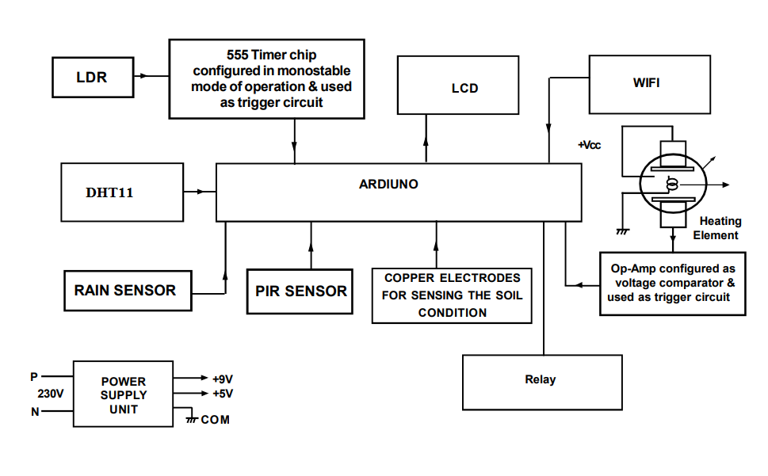
Block Diagram

DEPARTMENT DISPLAY BOARD USING MICROCONTROLLER 8051
S. MEGHANA (14R11A04N2)
M. GANESH REDDY (14R11A04L7)
J. SAI KRISHNA (15R15A0426)

Guide
Mr. A. Subramanyam
Assistant Professor

ABSTRACT
There are several types of scrolling message displays available in the market, but this is the one, which is quite different among all of them. This is innovative and entirely a different kind of project work, designed using advanced technology. The main purpose of the project work is to keep post the new message by erasing the old information through corresponding mobile phone through GSM technology. GSM based project works are gaining popularity because of its flexible advanced technology, any digital information regarding any process automation designed with digital electronics can be send to any desired mobile phone automatically throughout the world. The present systems are quite complicated; the customer himself cannot change the message, to do so he has to request the designer for changing the message. The common system is like this, when the display system is interfaced with computer, then with the help of keyboard, the message can be changed. This is little inconvenient for the customer, and moreover most of the display boards are arranged over the roof of buildings, and it is more difficult for the customer. To avoid all these problems, this project work is designed and the process is very simple, even a layman can also operate the system without going nearer to the display board.

The entire system is designed with three micro controller units, in addition to this, GSM module is essential to prove the concept. Nearly 120 pages software is loaded in different MC units. Aim is to control the main display board through mobile, since mobile communication network is used, the display board can be controlled anywhere from the world. The existing message can be cleared by sending fresh message from mobile; the received information will be stored in EEPROM, which remains as it is until it is erased from the mobile. New message in the form of SMS can be generated & transmitted through concern mobile phone. Power failures cannot be erase the data.

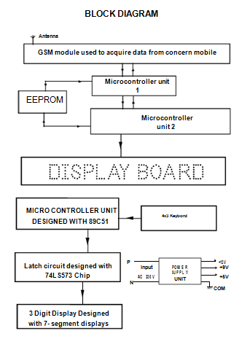

JAIL SECURITY SYSTEM
A.S.V.L.SANDHYA-14R11A04J2
M.RAGHAVENDRA-14R11A04L4
Y.SRI SAI ADITYA-14R11A04P2
Guide
Mrs. S.KRISHNA PRIYA
Associate Professor
ABSTRACT
The jail security system presented here is enclosed with innovative concepts can be used for different applications; the ultimate goal is to provide high level security to the jails. The same system can be used for other organizations where high level security is required.
The prototype module is constructed with three main concepts, in which top priority is given for the autonomous vehicle which roams with in the premises of jail that broadcast the live video to the monitoring station. This vehicle is equipped with 5 sets of IR sensors for detecting the objects & pits on its way. As the vehicle is designed as autonomous, it avoids collision with objects & takes diversions automatically. Whenever the vehicle finds any pit on its way, the vehicle will take diversion automatically & avoids falling in to it, for this purpose pit sensors are used. The wireless video camera arranged over the vehicle at its front side can turn around once at every fixed interval for guarding the surroundings. The vehicle will be stopped during rotation of the camera. The wireless video monitoring system that is supposed to be installed in a security room that contains one small B/W TV set along with its video receiver.
The second concept is to guard the sensitive points; here sensitive points are defined as the points from where prisoners may escape. Here also IR sensors are used for detecting the presence of persons during restricted hours. The prototype module is constructed with two reference points & provision is made for displaying the interrupted area through LCD. This equipment also can be installed in the security room. If any point is interrupted, alarm will be energized for a moment to alert the security, and interrupted area will be displayed. The third concept is to energize the outdoor lights automatically during dark; these lights will be energized in the evening & are de-energized in the morning.

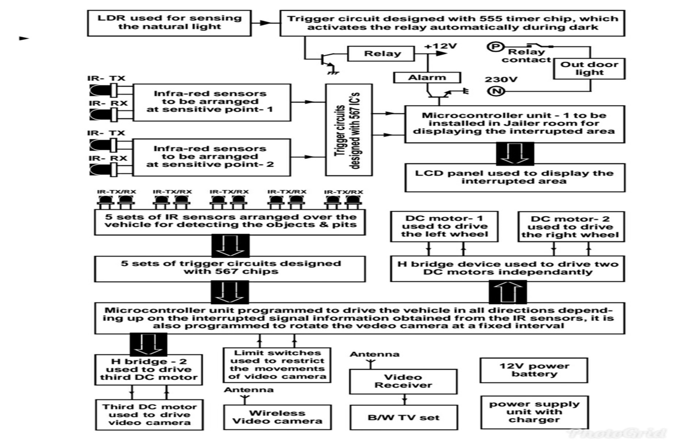

HOME APPLIANCES CONTROLLING USING ANDROID MOBILE WITH VOICE ACKNOWLEDGEMENT
CH NAGA SAI SUSHMITHA (14R11A0411)
KOLUKURI BHARGAVI (15R15A0403)
THAMADA ARUN KUMAR (14R11A0453)

Guide
Mr. V. Indu Priya
Assistant Professor

ABSTRACT
The project aims at designing and advanced home automation system using Wi-Fi technology .The devices can be switched ON/OFF using a SMART PHONE through Wi-Fi.
Today is a world of advanced ubiquitous mobile applications which are used exhaustively to save time & energy. These applications ease day-to-day life of common man. Based on these technologies and applications we designed a Home Automation System. In this paper, we propose design & prototype implementation of home automation system that uses Wi-Fi technology and android operating system. An attractive market for home automation system is for busy families and individuals with physical limitations. Users can control electrical appliances in home or office via SMARTPHONE.
Features:
- Wi-Fi based user friendly interfacing.
- Low power consumption.
- Controls High & Low voltage devices.
- Long-life.
