Project Based Learning (PBL)
Activities Carried out under PBL during 2019-20 – I semester
In an effort to bring innovation in Teaching-Learning-Process Project Based Learning is carried out in the following courses. Students with the help of faculty members completed the under-mentioned projects as part of PBL
Electronic Circuit Analysis and Design Lab (ECAD):
Three projects were submitted by II year students under project based learning (PBL) in Electronic Circuit Analysis and Design Lab (ECAD) by Group V (Analog Electronics) under the guidance of Dr.S.Suryanaraya.
Project titled “Transient response of RC low pass circuit using MATLAB”, submitted by C.V.G.Prasad Varma mentored by Ms.J.Mrudula.
Project titled “Design of low cost half wave rectifier with filter for a given ripple factor of 0.9”, submitted by M.Spandana, M.Srilekha and S.Sahithi mentored by Mr.U.Appalaraju.
Project titled “Selection of operating point from transistor data sheet and hence designing and verification of a self bias circuit for a given stability factor of 15”, was submitted by Ruchishawa mentored by Mr.U.Appalaraju.
Microwave Engineering:
Four projects were submitted by IV year students under project based learning (PBL) in Microwave Engineering by Group I (Fields and waves) under the guidance of Dr.R.S.Raju, Mr.R.V.N.R.Suneel Krishna and Mr.Ch.Suresh Kumar.
Project titled “Design of a rectangular waveguide for X-Band Applications”, by 48 students.
Project titled “Design of E-Plane Tee for X-Band Applications”, by 48 students.
Project titled “Design of H-Plane Tee for X-Band Applications”, by 48 students.
Project titled “Design of Magic Tee for X-Band Applications”, by 48 students.
Digital Design:
A Two day project competition was held in Digital Design under Project Based Learning on 10th and 11th October 2019 by Group IV (Digital Electronics) under the guidance of Prof.K.Somasekhara Rao, Mr.Ch.Sandeep and Mr.M.Anand.
S.No | Prize | Roll no. | Name of the  student | Project Title
1 | 1st | 18R11A0428 | K Tejaswi | Density based Automatic Traffic control system
2 |  | 18R11A0432 | M Keerthana
3 |  | 18R11A0446 | Y Saketh
4 | 2nd | 18R11A0488 | S Ramya | Smart Office
5 |  | 18R11A0490 | S Ruchishun
6 |  | 18R11A0478 | M Srilekha
7 | 3rd | 18R11A0473 | K Vishwesh | 2 bit Password checker
8 |  | 18R11A0475 | L Nithin
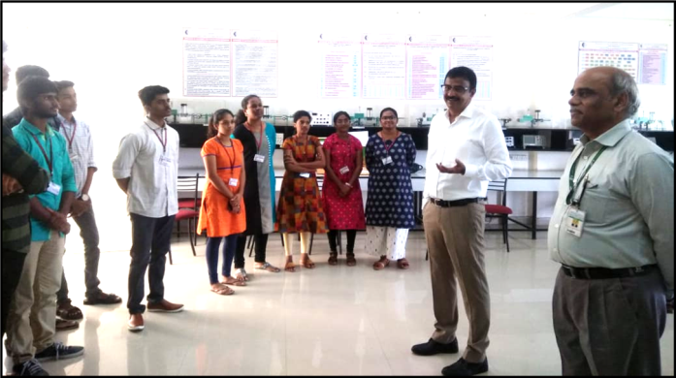 |  |  |  | 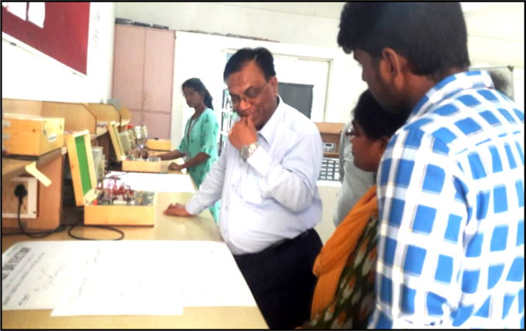

Antennas and Wave Propagation:
Five projects were submitted by III year students under project based learning (PBL) in Antennas by Group I (Fields and waves) under the guidance of Prof. B.Hari Kumar, Dr.B.L.Prakash, Mr.P.Naresh Kumar, Ms.A.Sowjanya.
Project titled “Design of Monopole Antenna for X-Band Operation”, by 183 students.
Project titled “Design of Dipole Antenna for X-Band Operation”, by 183 students.
Project titled “Design of Loop Antenna for X-Band Operation”, by 183 students.
Project titled “Design of Horn Antenna for X-Band Operation”, by 183 students.
Project titled “Design of Microstrip Antenna for X-Band Operation”, by 183 students.

The project based learning is successfully implemented in the course of Antennas and Wave Propagation by way of training the III ECE students in the HFSS software and MATLAB programming for the design and implementation of (i)Mono-Pole Antenna (ii) Dipole Antenna (iii)Horn Antenna (iv)Loop antenna (v) helical antenna (vi)Micro-strip patch antenna for X-band and (vii) Boe-Tie antenna. Some students are also trained in (a) Plotting the Radiation pattern of a Dipole Antenna using MATLAB (b) Plotting the Radiation pattern of a Loop Antenna using MATLAB and (c) Plotting the 3-D Radiation pattern of a Dipole Antenna using MATLAB.
The scanned copies of assigned batches and the projects that they have successfully implemented are given below. The summary of the role of the students and faculty is given below:
The designed antennas are fabricated with the help of ALRC-KLU, Vijayawada and theoretical results are compared with the practical results.

Design of Monopole Antenna for X-Band Operation  Guide:  III ECE-  A: P Naresh Kumar  B: A Sowjanya  C: Prof. B. Hari Kumar  E: P Naresh Kumar | The students will design the monopole antenna mathematically for selected frequency, then will test the parameter by drawing and simulating using HFSS software. Later student will analyze the concepts learned theoretically and compare with the obtained results. The deviations may be noted and analyzed. | i) Understand mathematical analysis  ii) Understand how to design using HFSS software  iii) Compare theoretical and practical results | • Status: Explained the process to students and they are practicing individually  • No of Batches:  III ECE – A: 12  III ECE – B: 19  III ECE – C: 18  III ECE – E: 12  Note: Each batch contains 3 students
Design of Dipole Antenna for X-Band Operation  Guide:  III ECE-  A: P Naresh Kumar  B: A Sowjanya  C: Prof. B. Hari Kumar  E: P Naresh Kumar | The student will design the dipole antenna mathematically for selected frequency, then will test the parameter by drawing and simulating using HFSS software. Later student will analyze the concepts learned theoretically and compare with the obtained results. The deviations may be noted and analyzed. | i) Understand mathematical analysis  ii) Understand how to design using HFSS software  iii) Compare theoretical and practical results | • Status: Explained the process to students and they are practicing individually  • No of Batches:  III ECE – A: 12  III ECE – B: 19  III ECE – C: 18  III ECE – E: 12  Note: Each batch contains 3 students
Design of Loop Antenna for X-Band Operation  Guide:  III ECE-  A: P Naresh Kumar  B: A Sowjanya  C: Prof. B. Hari Kumar  E: P Naresh Kumar | The student will design the loop antenna mathematically for selected frequency, then will test the parameter by drawing and simulating using HFSS software. Later student will analyze the concepts learned theoretically and compare with the obtained results. The deviations may be noted and analyzed. | i) Understand mathematical analysis  ii) Understand how to design using HFSS software  iii) Compare theoretical and practical results | • Status: Explained the process to students and they are practicing individually  • No of Batches:  III ECE – A: 12  III ECE – B: 19  III ECE – C: 18  III ECE – E: 12  Note: Each batch contains 3 students
Design of Horn Antenna for X-Band Operation  Guide:  III ECE-  A: P Naresh Kumar  B: A Sowjanya  C: Prof. B. Hari Kumar  E: P Naresh Kumar | The student will design the horn antenna mathematically for selected frequency, then will test the parameter by drawing and simulating using HFSS software. Later student will analyze the concepts learned theoretically and compare with the obtained results. The deviations may be noted and analyzed. | i) Understand mathematical analysis  ii) Understand how to design using HFSS software  iii) Compare theoretical and practical results | • Status: Explained theoretical concepts. Design process using HFSS need to be explained. Manual preparation completed.
Design of Helical Antenna for X-Band Operation  Guide:  III ECE-  A: P Naresh Kumar  B: A Sowjanya  C: Prof. B. Hari Kumar  E: P Naresh Kumar | The student will design the Helical antenna mathematically for selected frequency, then will test the parameter by drawing and simulating using HFSS software. Later student will analyze the concepts learned theoretically and compare with the obtained results. The deviations may be noted and analyzed. | i) Understand mathematical analysis  ii) Understand how to design using HFSS software  iii) Compare theoretical and practical results | • Status: Explained theoretical concepts. Design process using HFSS need to be explained. Manual preparation completed.
Design of Microstrip Patch Antenna for X-Band Operation  Guide:  III ECE-  A: P Naresh Kumar  B: A Sowjanya  C: Prof. B. Hari Kumar  E: P Naresh Kumar | The student will design the patch antenna mathematically for selected frequency, then will test the parameter by drawing and simulating using HFSS software. Later student will analyze the concepts learned theoretically and compare with the obtained results. The deviations may be noted and analyzed. | i) Understand mathematical analysis  ii) Understand how to design using HFSS software  iii) Compare theoretical and practical results | • Status: Explained theoretical concepts. Design process using HFSS need to be explained. Manual need to be prepared .
Plotting the 2D Radiation pattern of a Dipole Antenna using MATLAB  Guide:  III ECE-D : Dr. B. L. Prakash | The students have written a program in MATLAB and plotted the 2D radiation pattern of the given Dipole antenna for any given dimensions | Understand mathematical analysis of Radiation pattern and implementation using MATLAB | Status: Explained theoretical concepts
Plotting the Radiation pattern of a Loop Antenna using MATLAB  III ECE-D : Dr. B. L. Prakash | The students have written a program in MATLAB and plotted the Loop pattern of the given Dipole antenna for any given dimensions | Understand mathematical analysis of Radiation pattern and implementation using MATLAB | Status: Explained theoretical concepts
Plotting the 3-D Radiation pattern of a Dipole Antenna using MATLAB.  III ECE-D : Dr. B. L. Prakash | The students have written a program in MATLAB and plotted the radiation pattern of the given Dipole antenna for any given dimensions | Understand mathematical analysis of Radiation pattern and implementation using MATLAB | Status: Explained theoretical concepts

